Asia-China-Shang-Bronze-Elephant

Zun is a wine container in ancient China that could vary from large to medium size. It is formed having ring feet, with belly that could be round or rectangular, a long neck, and an unsealed mouth with big caliber. Zun became a fashion since the Shang Dynasty until the Western Zhou Dynasty, but its popularity decreased after late Spring and Autumn period. Among all unearthed Zun, Siyang, a rectangular Zun, otherwise known as four-goat rectangular Zun captured the interest of most people.  
Besides Zun, another specially-structured ancient wine vessel called Xizun ( sacrifice Zun in English )was found throughout Shang Dynasty ,Western Zhou Dynasty, and Warring States Period. This goblet varies in many forms, including an ox form, a goat, a tiger, an elephant or a phoenix. A sacrifice Zun, which is magnificently ornamented with an animal-back-shape or animal-head-shape lid, is practical as a vessel and precious as a craftwork.  
If you could take a look at the majestically-standing elephant carved with taotie design, you would notice its long stretching nose having its nostril raised towards its mouth. Its back, on which a merry bird is dancing, is used as a Zun lid.  
In history, an elephant-shape Zun are rare. Hunan Museum is home to such Zuns with radical differences from one another. This craft work, which everyone may appreciate, is indeed a treasure.

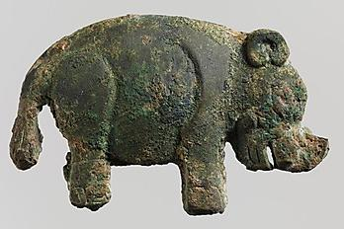

Elephant relief in bronze.

Shang dynasty, ca. 1600-1046 B.C., China.

In early China, elephants were very common throughout the area. When the Han and Tang dynasties and rolled by, however, economic growth shrunk the habitat of the elephant until it was almost exclusively found near or south of the Yangtze and Qiantang rivers. After this period, the import of tamed elephants from India became a fixture for emperors, some of them boasting their incredible collection of these animals.

(Source: [The Metropolitan Museum of Art](http://www.metmuseum.org/))

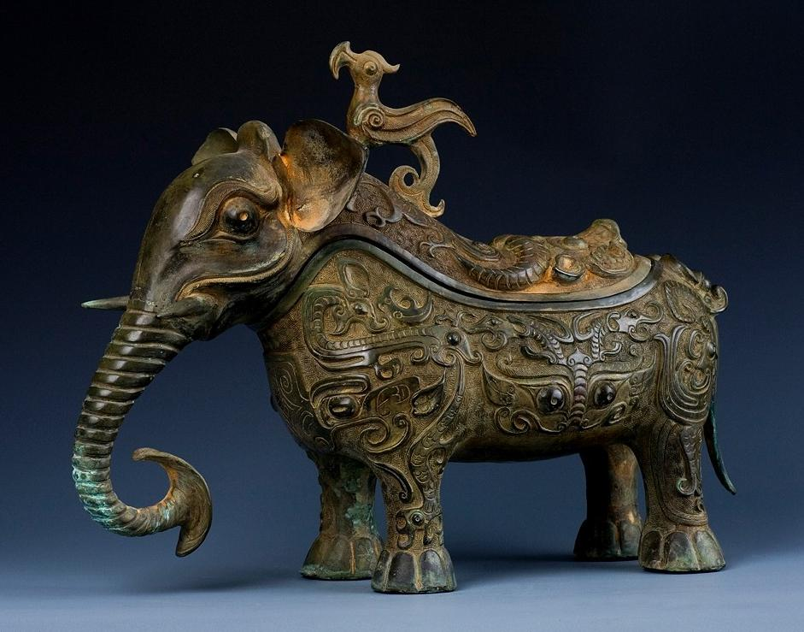 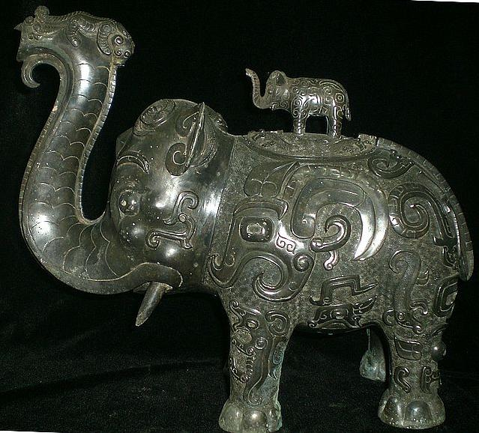 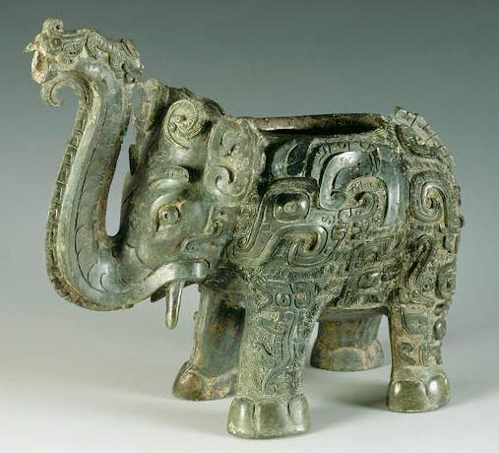

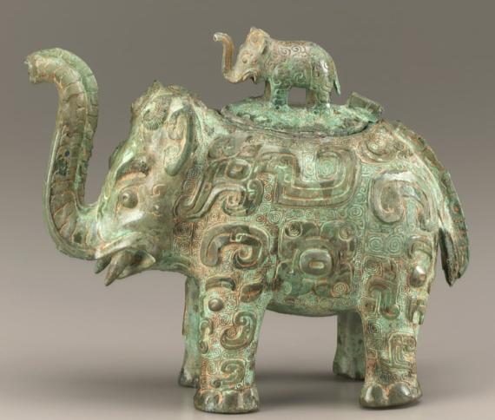

**Lidded ritual ewer (*huo*) in the form of an elephant with masks and dragons**

ca. first half 11th century B.C.E.  
  
Shang dynasty   
Late Anyang period  
  
Bronze  
H: 4.9 W: 4.2 D: 8.1 cm   
Middle Yangzi Valley, China   
  
F1936.6a-b

Smithsonian Freer Sackler

